ASSIGNMENT-3.1
Name:K.Sunny
B-13
2303A51864

Task 1: Zero-Shot Prompting (Palindrome Number Program)
Prompt: write a python function to check given number is palindrome or not return output int Tr ue or False. Provide code in user input.
Code with output:
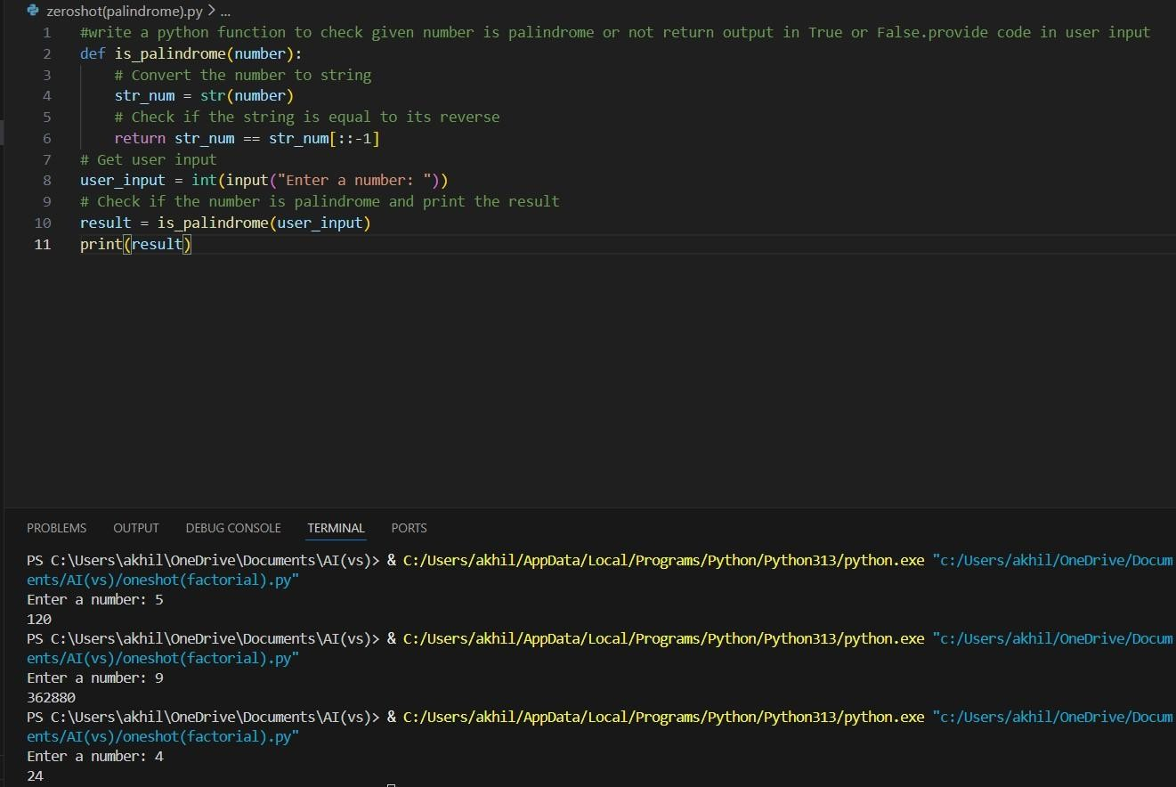
Justification:
- Correct for positive numbers
- Negative numbers not handled clearly
- No input validation for non-integers
Task 2: One-Shot Prompting (Factorial Calculation)
Prompt: write a python function to calculate factorial of given number. Example: input=5 ; output=120
Code with output:
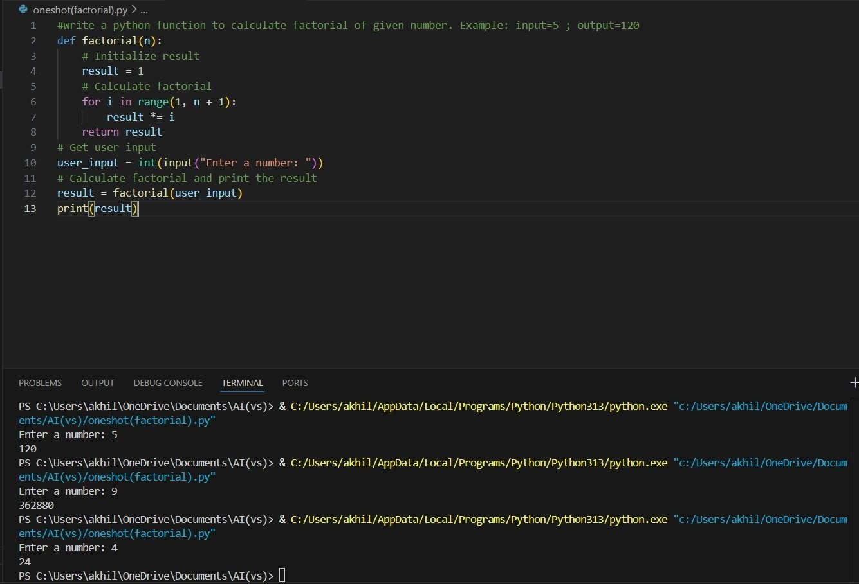
Justification:
- One-shot gives clearer logic
- More readable and reliable

Task 3: Few-Shot Prompting (Armstrong Number Check)
Code with output:
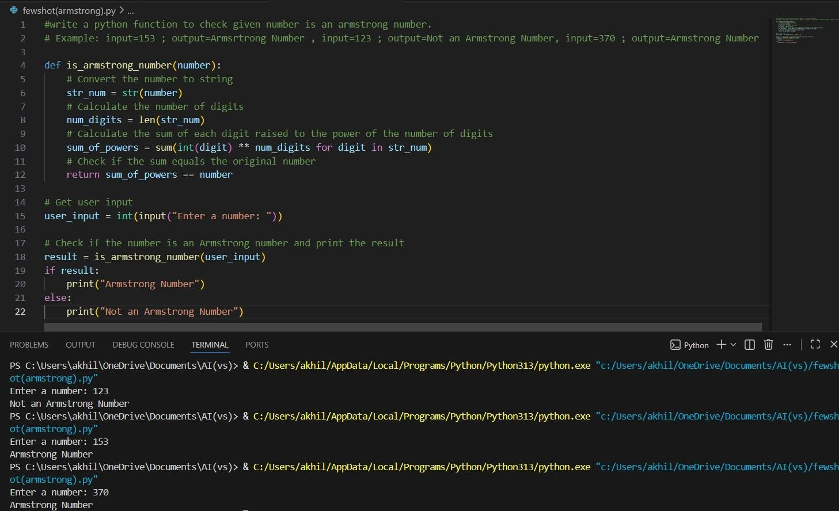
Justification:
- Few-shot improves accuracy
- Code structure matches examples
- Still lacks input validation for negatives

Task 4: Context-Managed Prompting (Optimized Number
Classification)
Prompt: generate an optimized python program that classifies a number is prime, composite or neither Code with output:
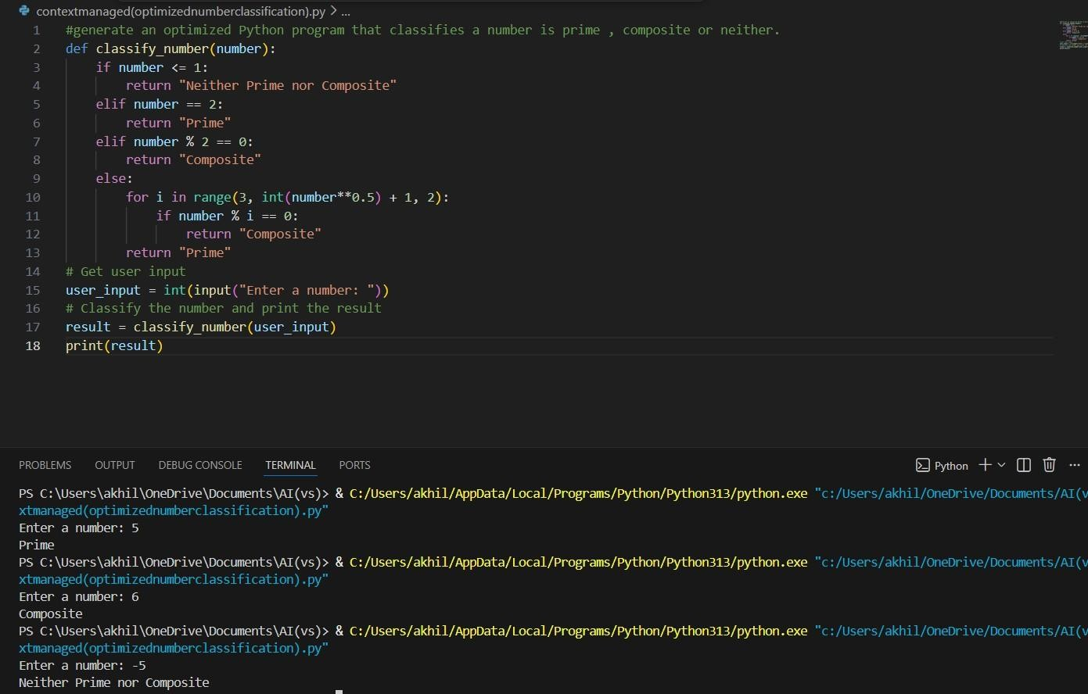
Justification:
- Best performance among all prompts
- Clear validation and optimized logic
- Context improves efficiency and correctness

Task 5: Zero-Shot Prompting (Perfect Number Check)
Prompt:generate a python function to check given number is a perfect number.
Code with output:
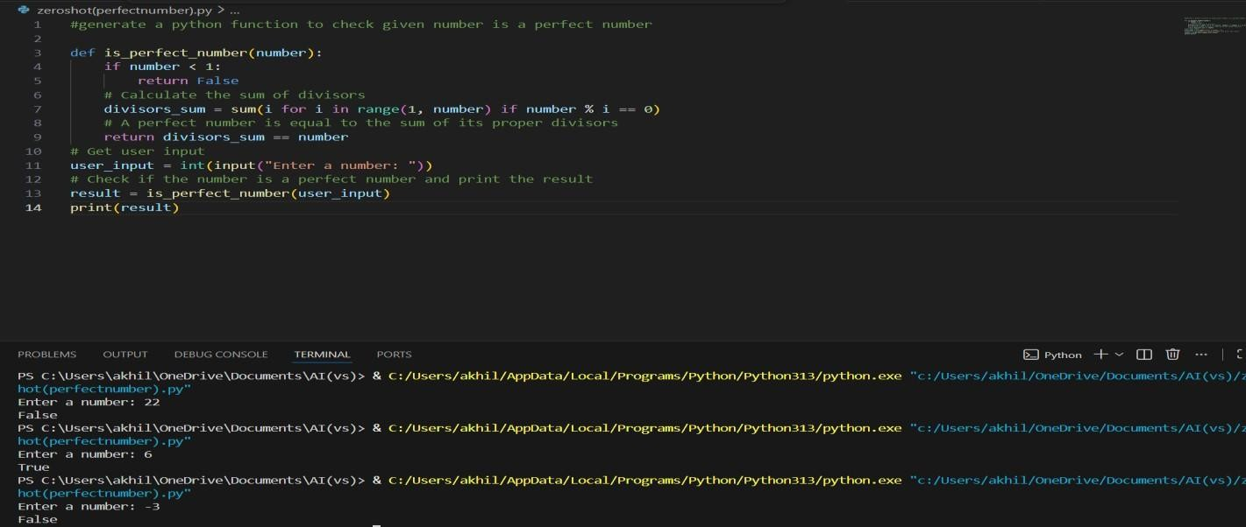

Task 6: Few-Shot Prompting (Even or Odd Classification with
Validation)
Code with output:
